– 数据源
/* create database test50;
use test50;
create table Student(sid varchar(10),sname varchar(10),sage datetime,ssex nvarchar(10));
insert into Student values(‘01’ , ‘赵雷’ , ‘1990-01-01’ , ‘男’);
insert into Student values(‘02’ , ‘钱电’ , ‘1990-12-21’ , ‘男’);
insert into Student values(‘03’ , ‘孙风’ , ‘1990-05-20’ , ‘男’);
insert into Student values(‘04’ , ‘李云’ , ‘1990-08-06’ , ‘男’);
insert into Student values(‘05’ , ‘周梅’ , ‘1991-12-01’ , ‘女’);
insert into Student values(‘06’ , ‘吴兰’ , ‘1992-03-01’ , ‘女’);
insert into Student values(‘07’ , ‘郑竹’ , ‘1989-07-01’ , ‘女’);
insert into Student values(‘08’ , ‘王菊’ , ‘1990-01-20’ , ‘女’);
create table Course(cid varchar(10),cname varchar(10),tid varchar(10));
insert into Course values(‘01’ , ‘语文’ , ‘02’);
insert into Course values(‘02’ , ‘数学’ , ‘01’);
insert into Course values(‘03’ , ‘英语’ , ‘03’);
create table Teacher(tid varchar(10),tname varchar(10));
insert into Teacher values(‘01’ , ‘张三’);
insert into Teacher values(‘02’ , ‘李四’);
insert into Teacher values(‘03’ , ‘王五’);
create table SC(sid varchar(10),cid varchar(10),score decimal(18,1));
insert into SC values(‘01’ , ‘01’ , 80);
insert into SC values(‘01’ , ‘02’ , 90);
insert into SC values(‘01’ , ‘03’ , 99);
insert into SC values(‘02’ , ‘01’ , 70);
insert into SC values(‘02’ , ‘02’ , 60);
insert into SC values(‘02’ , ‘03’ , 80);
insert into SC values(‘03’ , ‘01’ , 80);
insert into SC values(‘03’ , ‘02’ , 80);
insert into SC values(‘03’ , ‘03’ , 80);
insert into SC values(‘04’ , ‘01’ , 50);
insert into SC values(‘04’ , ‘02’ , 30);
insert into SC values(‘04’ , ‘03’ , 20);
insert into SC values(‘05’ , ‘01’ , 76);
insert into SC values(‘05’ , ‘02’ , 87);
insert into SC values(‘06’ , ‘01’ , 31);
insert into SC values(‘06’ , ‘03’ , 34);
insert into SC values(‘07’ , ‘02’ , 89);
insert into SC values(‘07’ , ‘03’ , 98);

*/

– 50题及答案

– 1.查询“某1”课程比“某2”课程成绩高的所有学生的学号；
SELECT a.sid FROM (SELECT * FROM sc WHERE cid=‘01’)a LEFT JOIN
(SELECT * FROM SC WHERE cid=‘02’)b ON a.sid=b.sid
WHERE a.score > b.score

– 2.查询平均成绩大于60分的同学的学号和平均成绩；
SELECT a.sid,AVG(a.score) 平均分 FROM sc a GROUP BY a.sid HAVING AVG(a.score)>60

– 3.查询所有同学的学号、姓名、选课数、总成绩
SELECT a.sid,a.sname,IFNULL(b.cid,0) 选课数,IFNULL(b.score,0) 总分 FROM student a LEFT JOIN
(SELECT sid,COUNT(cid) cid,SUM(score) score FROM sc GROUP BY sid ) b ON a.sid =b.sid

– 4.查询姓“李”的老师的个数；
SELECT COUNT(1) FROM teacher WHERE tname LIKE ‘李%’;

– 5.查询没学过“张三”老师课的同学的学号、姓名；
SELECT sid ,sname FROM student WHERE sid NOT IN(
SELECT b.sid FROM sc b LEFT JOIN course c ON b.cid=c.cid
LEFT JOIN teacher d ON c.tid=d.tid
WHERE d.tname=‘张三’)
– 6.查询学过语文并且也学过数学课程的同学的学号、姓名；
SELECT c.sid,c.sname FROM student c INNER JOIN
(SELECT a.sid FROM sc a LEFT JOIN course b ON a.cid =b.cid WHERE b.cname=‘语文’)a
ON c.sid=a.sid
INNER JOIN
(SELECT a.sid FROM sc a LEFT JOIN course b ON a.cid =b.cid WHERE b.cname=‘英语’)b
ON c.sid=b.sid

– 7.查询学过“张三”老师所教的所有课的同学的学号、姓名；
SELECT a.sid,a.sname FROM student a,
(SELECT a.sid FROM sc a,course b,Teacher c WHERE a.cid= b.cid AND a.cid=c.tid AND c.tname=‘张三’) b
WHERE a.sid=b.sid

– 8.查询课程编号“01”的成绩比课程编号“02”课程低的所有同学的学号、姓名；
SELECT a.sid,a.sname FROM
(SELECT a.sid,a.cid,a.score,b.sname FROM sc a,student b WHERE cid=‘01’ AND a.sid=b.sid)a LEFT JOIN
(SELECT a.sid,a.cid,a.score,b.sname FROM sc a,student b WHERE cid=‘02’ AND a.sid=b.sid)b
ON a.sid=b.sid WHERE a.score<b.score

– 9.查询所有课程成绩小于60分的同学的学号、姓名；
SELECT DISTINCT a.sid,a.sname FROM student a ,sc b WHERE a.sid=b.sid AND b.score<60

– 10.查询没有学全所有课的同学的学号、姓名；
SELECT a.sid,a.sname FROM student a ,
(SELECT sid,COUNT(cid) FROM sc GROUP BY sid HAVING COUNT(cid)< (SELECT COUNT(1) FROM course))b
WHERE a.sid=b.sid

– 11.查询至少有一门课与学号为“01”的同学所学相同的同学的学号和姓名；
– 先查询到01同学学了哪些课程
SELECT DISTINCT b.sid,a.sname FROM student a LEFT JOIN sc b
ON a.sid=b.sid WHERE b.cid IN(
SELECT cid FROM sc WHERE sid=‘01’) AND b.sid!= ‘01’

– 12.查询和"01"号的同学学习的课程完全相同的其他同学的学号和姓名
– 先查询01号同学学习的课程信息
SELECT SID,SNAME FROM student WHERE sid IN(
SELECT sid FROM sc WHERE sid!=‘01’ AND cid IN
(SELECT cid FROM sc WHERE sid=‘01’) GROUP BY sid
HAVING COUNT()=(SELECT COUNT() FROM SC WHERE SID=‘01’)
)

– 13.把“SC”表中“张三”老师教的课的成绩都更改为此课程的平均成绩；
– 查询张三老师教的课程

BEGIN; – 开启事务
UPDATE sc SET score= (SELECT avg_score FROM
(SELECT AVG(score) avg_score FROM sc WHERE cid =
(SELECT cid FROM course a ,teacher b WHERE a.tid=b.tid AND b.tname=‘张三’)
GROUP BY cid)e)
WHERE cid=
(SELECT cid FROM course a ,teacher b WHERE a.tid=b.tid AND b.tname=‘张三’)
ROLLBACK; – 回滚
COMMIT; – 提交

– 14、查询没学过"张三"老师讲授的任一门课程的学生姓名
– 查询到张三老师讲的课程
SELECT sid,sname FROM student WHERE sid NOT IN(
SELECT sid FROM sc WHERE cid IN(
SELECT cid FROM course a,teacher b WHERE a.tid=b.tid AND b.tname=‘张三’))

– 15、查询两门及其以上不及格课程的同学的学号，姓名及其平均成绩
– 查询不及格课程的同学
SELECT a.sid,a.sname,b.avg_score FROM student a LEFT JOIN
(SELECT sid,score,COUNT(cid) num,AVG(score) avg_score FROM sc GROUP BY sid HAVING score<60 )b
ON a. sid=b.sid WHERE b.num>=2

– 16、检索"01"课程分数小于60，按分数降序排列的学生信息
SELECT * FROM student a INNER JOIN
(SELECT sid,score FROM sc WHERE cid=‘01’ AND score<60 ORDER BY score DESC)b
ON a.sid =b.sid

– 17、按平均成绩从高到低显示所有学生的所有课程的成绩以及平均成绩
– case when实现行列转换时会出现多条记录，如果不用聚合函数MAX() 直接进行group by分组，
– 那么检索的是基表里分组字段的第一条记录，如果使用max()函数之后再进行group by分组，
– 那么就会检索每个字段的最大值然后再分组
SELECT a.sname,b.* FROM student a INNER JOIN (
SELECT sid,
MAX(CASE b.cid WHEN ‘01’ THEN b.score ELSE 0 END) AS 语文,
MAX(CASE b.cid WHEN ‘02’ THEN b.score ELSE 0 END) AS 数学,
MAX(CASE b.cid WHEN ‘03’ THEN b.score ELSE 0 END) AS 英语,
IFNULL(CAST(SUM(b.score)/3 AS DECIMAL(18,2)),0) 平均分 FROM sc b
GROUP BY b.sid ORDER BY 平均分 DESC) b ON a.sid=b.sid

– 18.查询各科成绩最高分、最低分和平均分：以如下形式显示：课程ID，课程name，最高分，最低分，平均分，及格率，中等率，优良率，优秀率
SELECT a.cid,b.cname,MAX(a.score) 最高分,MIN(a.score) 最低分,CAST(AVG(a.score) AS DECIMAL(18,2)) 平均分,
CAST(SUM(CASE WHEN a.score>=60 THEN 1 ELSE 0 END) /COUNT() AS DECIMAL(18,2)) 及格率,
CAST(SUM(CASE WHEN a.score>=70 THEN 1 ELSE 0 END)/COUNT() AS DECIMAL(18,2)) 中等率,
CAST(SUM(CASE WHEN a.score>=80 THEN 1 ELSE 0 END)/COUNT() AS DECIMAL(18,2)) 优良率,
CAST(SUM(CASE WHEN a.score>=90 THEN 1 ELSE 0 END)/COUNT() AS DECIMAL(18,2)) 优秀率
FROM sc a LEFT JOIN course b ON a.cid=b.cid GROUP BY cid

– 19.按各科平均成绩从低到高和及格率的百分数从高到低顺序
SELECT cid,AVG(score) 平均分,
SUM(CASE WHEN score>=60 THEN 1 ELSE 0 END)/COUNT(*) 及格率
FROM sc GROUP BY cid ORDER BY 平均分 ASC,及格率 DESC

– 20、查询学生的总成绩并进行排名
– s.s1score>t.s2score 每一次比较都是s表的所有记录,跟t表的每一行去对比
– 方式一：
SELECT a.sid,a.sname,b.总分,b.排名 FROM student
a ,
(
SELECT t.sid,t.s2score 总分,
(SELECT COUNT(s.s1score)+1 FROM (SELECT sid ,SUM(score) s1score FROM sc GROUP BY sid) s WHERE s.s1score>t.s2score) 排名
FROM
(SELECT sid ,SUM(score) s2score FROM sc GROUP BY sid) t ORDER BY s2score DESC
)b
WHERE a.sid=b.sid ORDER BY 排名;

– 方式二：
SELECT s.,zf AS 总分,pm 排名 FROM Student s INNER JOIN
(
SELECT a.SID,a.zf,COUNT() AS pm FROM
(SELECT s.sid,IFNULL(SUM(score),0) zf FROM sc s GROUP BY s.sid) a ,
(SELECT s.sid,IFNULL(SUM(score),0) zf FROM sc s GROUP BY s.sid) b
WHERE a.zf<=b.zf GROUP BY a.SID
) b ON s.SID =b.SID ORDER BY pm

– 21、查询不同老师所教不同课程平均分从高到低显示
SELECT c.tname,b.cname,AVG(score) FROM sc a
INNER JOIN course b ON a.cid=b.cid INNER JOIN teacher c
ON b.tid=c.tid GROUP BY a.cid ORDER BY AVG(score) DESC

– 22、查询所有课程的成绩第2名到第3名的学生信息及该课程成绩
– 与排名的写法思想一致
SELECT s.sid,s.sname,t.cid,t.score,t.排名 FROM student s
INNER JOIN
(SELECT sid,cid,score,(SELECT COUNT(DISTINCT score) FROM sc b WHERE a.cid=b.cid AND a.score>b.score ) 排名
FROM sc a WHERE
(SELECT COUNT(DISTINCT score) FROM sc b WHERE a.cid=b.cid AND a.score>b.score ) BETWEEN
2 AND 3 ORDER BY cid) t ON s.sid=t.sid

– 23、统计各科成绩各分数段人数：课程编号,课程名称,[100-85],[85-70],[70-60],[0-60]及所占百分比
SELECT sc.cid,course.cname,
SUM(CASE WHEN score>=85 THEN 1 ELSE 0 END) ‘[100-85]’ ,
SUM(CASE WHEN score>=85 THEN 1 ELSE 0 END)/COUNT() ‘[100-85]百分比’,
SUM(CASE WHEN score>=70 AND score<85 THEN 1 ELSE 0 END) ‘[85-70]’ ,
SUM(CASE WHEN score>=70 AND score<85 THEN 1 ELSE 0 END)/COUNT() ‘[85-70]百分比’,
SUM(CASE WHEN score>=60 AND score<70 THEN 1 ELSE 0 END) ‘[70-60]’ ,
SUM(CASE WHEN score>=60 AND score<70 THEN 1 ELSE 0 END)/COUNT() ‘[70-60]百分比’,
SUM(CASE WHEN score<60 THEN 1 ELSE 0 END) ‘[0-60]’ ,
SUM(CASE WHEN score<60 THEN 1 ELSE 0 END)/COUNT() ‘[0-60]百分比’
FROM sc INNER JOIN course ON sc.cid=course.cid GROUP BY cid

– 24、查询学生平均成绩及其名次
SELECT s.sid,s.sname,t.ag2 平均分,t.排名 FROM
student s INNER JOIN
(
SELECT sid,ag2,
(SELECT COUNT(*)+1 FROM (SELECT sid,AVG(score) ag1 FROM sc GROUP BY sid) a WHERE a.ag1>b.ag2 ) 排名
FROM (SELECT sid,AVG(score) ag2 FROM sc GROUP BY sid) b
) t
ON s.sid=t.sid ORDER BY 排名

– 25、查询各科成绩前三名的记录
SELECT s.sname,c.cname,t.score,t.排名 FROM student s INNER JOIN
(SELECT sid,cid,score,
(SELECT COUNT(DISTINCT score)+1 FROM sc a WHERE a.score> b.score AND a.cid=b.cid ) 排名
FROM sc b WHERE
(SELECT COUNT(DISTINCT score)+1 FROM sc a
WHERE a.score> b.score AND a.cid=b.cid) BETWEEN 1 AND 3
ORDER BY cid ,排名
)t ON s.sid=t.sid
INNER JOIN course c
ON t.cid=c.cid

– 26.查询每门课程被选修的学生数
SELECT course.cid,course.cname,COUNT(*)学生数 FROM sc
INNER JOIN
course ON sc.cid=course.cid GROUP BY cid

– 27.查询出只选修了二门课程的全部学生的学号和姓名
– 方式一：
SELECT s.sid,s.sname FROM student s INNER JOIN
(SELECT sid,COUNT(cid) FROM sc GROUP BY sid HAVING COUNT(cid)=2) t
ON s.sid =t.sid
– 方式二：
SELECT *,COUNT(cid) 选课数 FROM student s INNER JOIN sc t
ON s.sid =t.sid GROUP BY t.sid HAVING COUNT(cid)=2

– 28、查询男生、女生人数
SELECT COUNT(ssex=‘女’)女生数,COUNT(ssex=‘男’)男生数 FROM Student;

– 29、查询名字中含有"风"字的学生信息
SELECT * FROM student WHERE sname LIKE ‘%风%’

– 30、查询同名同性学生名单，并统计同名人数
SELECT sname,ssex FROM student GROUP BY sname,ssex HAVING COUNT(1)>1

– 31、查询1990年出生的学生名单(注：Student表中Sage列的类型是datetime)
SELECT * FROM student WHERE YEAR(sage)=1990

– 32.查询每门课程的平均成绩，结果按平均成绩升序排列，平均成绩相同时，按课程号降序排列
SELECT cid,AVG(score) FROM sc GROUP BY cid ORDER BY AVG(score),cid DESC

– 33、查询平均成绩大于等于85的所有学生的学号、姓名和平均成绩
SELECT a.sid,a.sname,CAST(AVG(score) AS DECIMAL(18,1)) 平均分 FROM student a INNER JOIN sc b
ON a.sid=b.sid GROUP BY b.sid HAVING AVG(score)>=85

– 34、查询课程名称为"数学"，且分数低于60的学生姓名和分数
SELECT a.sid,a.sname,b.cname,c.score FROM student a,course b,sc c
WHERE a.sid=c.sid AND b.cid=c.cid AND c.score<60 AND b.cname=‘数学’

– 35、查询所有学生的课程及分数情况；
SELECT a.sname,
MAX(CASE WHEN b.cid=01 THEN b.score ELSE 0 END) 语文,
MAX(CASE WHEN b.cid=02 THEN b.score ELSE 0 END) 数学,
MAX(CASE WHEN b.cid=03 THEN b.score ELSE 0 END) 英语
FROM student a LEFT JOIN sc b
ON a.sid=b.sid GROUP BY a.sid

– 36、查询任何一门课程成绩在70分以上的姓名、课程名称和分数；
SELECT * FROM(
SELECT a.sname,
MAX(CASE WHEN b.cid=01 THEN b.score ELSE NULL END) 语文,
MAX(CASE WHEN b.cid=02 THEN b.score ELSE NULL END) 数学,
MAX(CASE WHEN b.cid=03 THEN b.score ELSE NULL END) 英语
FROM student a
INNER JOIN sc b ON a.sid=b.sid
INNER JOIN course c ON b.cid=c.cid
GROUP BY a.sid
) t WHERE t.语文>70 AND t.数学>70 AND t.英语>70

– 37.查询不及格的课程，并按课程号从大到小排列
SELECT cid,score FROM sc WHERE score<60 ORDER BY cid DESC

– 38.查询课程编号为"01"且课程成绩在60分以上的学生的学号和姓名；
SELECT s.sid,s.sname FROM student s INNER JOIN sc c ON s.sid=c.sid
WHERE c.score>=60 AND c.cid=‘01’

– 39、求每门课程的学生人数
SELECT cid, COUNT(sid)学生数 FROM sc GROUP BY cid

– 40.查询选修“张三”老师所授课程的学生中，成绩最高的学生姓名及其成绩
SELECT a.sname,c.cname,d.tname, MAX(b.score)分数 FROM student a
LEFT JOIN sc b ON a.sid=b.sid
LEFT JOIN course c ON b.cid=c.cid
LEFT JOIN teacher d ON c.tid=d.tid
WHERE d.tname=‘张三’

– 41、查询不同课程成绩相同的学生的学生编号、课程编号、学生成绩
– 先查出sc表用,每个学生的成绩中,有相同分数的学生
– SELECT sid,cid,score FROM sc GROUP BY sid,score HAVING COUNT()>1
SELECT a. FROM sc a,
(SELECT sid,cid,score FROM sc GROUP BY sid,score HAVING COUNT(*)>1)b
WHERE a.sid=b.sid

– 42、查询每门功成绩最好的前两名
SELECT a.cid,a.sid,a.score,COUNT(DISTINCT b.score) 排名 FROM sc a,sc b
WHERE a.cid=b.cid AND a.score<=b.score
GROUP BY a.sid, a.cid HAVING COUNT(1)❤️ ORDER BY cid,COUNT(1)

– 43、统计每门课程的学生选修人数（超过5人的课程才统计）。
– 要求输出课程号和选修人数，查询结果按人数降序排列，若人数相同，按课程号升序排列
SELECT cid,COUNT(sid)人数 FROM sc GROUP BY cid HAVING COUNT(sid)>5
ORDER BY COUNT(sid) DESC,cid

– 44、检索至少选修两门课程的学生学号
SELECT sid,COUNT(cid)选课数 FROM sc GROUP BY sid HAVING COUNT(cid)>=2

– 45、查询选修了全部课程的学生信息
SELECT a.* FROM student a INNER JOIN sc b
ON a.sid=b.sid GROUP BY b.sid HAVING COUNT(1)=(SELECT COUNT(1) FROM course)

– 46、查询各学生的年龄
SELECT *,YEAR(FROM_DAYS(DATEDIFF(NOW(),sage)))年龄 FROM student;

– 47、查询本周过生日的学生
SELECT * FROM student WHERE WEEK(SAGE)=WEEK(NOW())

– 48、查询下周过生日的学生
SELECT * FROM student WHERE WEEK(SAGE)=WEEK(NOW())+1

– 49、查询本月过生日的学生
SELECT * FROM STUDENT WHERE MONTH(SAGE)=MONTH(NOW())

– 50、查询下月过生日的学生
SELECT * FROM STUDENT WHERE MONTH(SAGE)=MONTH(NOW())+1

51 设有商店和顾客两个实体，“商店”有属性：商店编号、商店名、地址、电话，“顾客”有属性：顾客编号、姓名、地址、年龄、性别。假设一个商店有多个顾客购物，一个顾客可以到多个商店购物，顾客每次去商店购物有一个消费金额和日期，而且规定每个顾客在每个商店里每天最多消费一次。

①试画出ER图，并注明属性和联系类型。

52假设每个学生选修若干门课程，且每个学生每选一门课只有一个成绩，每个教师只担任一门课的教学,一门课由若干教师任教。“学生”有属性：学号、姓名、地址、年龄、性别。“教师”有属性：职工号、教师姓名、职称，“课程”有属性：课程号、课程名。
①试画出ER图，并注明属性和联系类型。
②将E-R图转换成关系模型 ，并注明主码和外码

关系模型

学生（学号，姓名，地址，年龄，性别）

课程（课程号，课程名）

教师（职工号，职工姓名，职称）

选课（学号，课程号，成绩）

授课（职工号，课程号）

主码和外码

学生：学号（主码）；

课程：课程号（主码）；

教师：职工号（主码）；

选课：（学号，课程号）（主码）；学号（外码），课程号（外码）；

授课：（职工号，课程号）（主码）；职工号（外码），课程号（外码）。

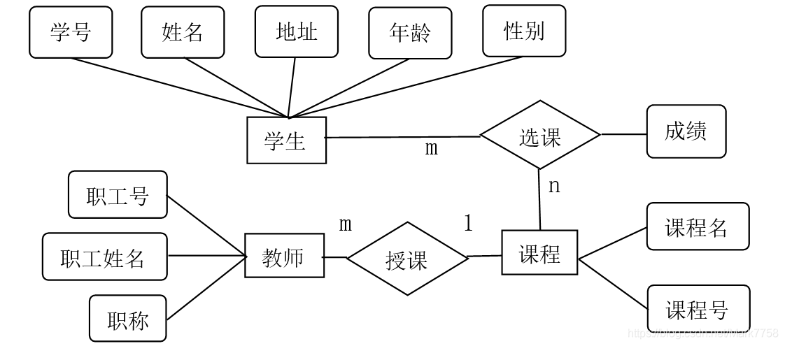
53
现有学生报考系统，实体“考生”有属性：准考证号、姓名、年龄、性别，实体“课程”有属性：课程编号、名称、性质。一名考生可以报考多门课程，考生报考还有报考日期、成绩等信息。
①试画出ER图，并注明属性和联系类型。
②将E-R图转换成关系模型 ，并注明主码和外码

关系模型

考生（准考证号，姓名，年龄，性别）

课程（课程编号，名称，性质）

报考（准考证号，课程编号，报考日期，成绩）

主码和外码

考生：准考证号（主码）；

课程：课程编号（主码）；
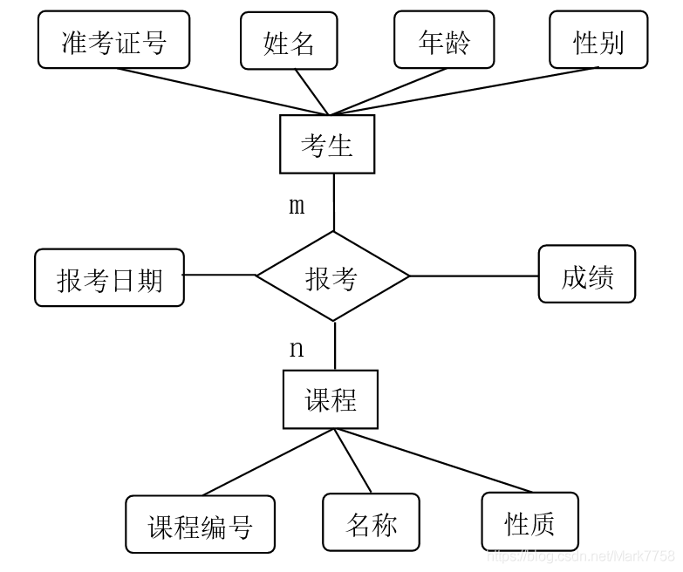

54设有运动员和比赛项目两个实体，“运动员”有属性：运动员编号、姓名、单位、性别、年龄，“比赛项目”有属性：项目号、名称、最好成绩。一个运动员可以参加多个项目，一个项目由多名运动员参加，运动员参赛还包括比赛时间、比赛成绩等信息。
①试画出ER图，并注明属性和联系类型。
②将E-R图转换成关系模型 ，并注明主码和外码

关系模型

运动员（运动员编号，姓名，单位，性别，年龄）

比赛项目（项目号，名称，最好成绩）

参赛（运动员编号，项目号，比赛时间，比赛成绩）

主码和外码

运动员：运动员编号（主码）；

比赛项目：项目号（主码）；

参赛：（运动员编号，项目号）（主码）；运动员编号（外码），项目号（外码）。
